|  |  |  |
| --- | --- | --- |
| **Question 1** |  | 1 / 1 point |

The battery terminal with an excess of negatively charged electrons is the Negative Terminal

|  |  |  |  |
| --- | --- | --- | --- |
|  | False | | |
|  | True | | |
| **Question 2** | |  | 1 / 1 point | |

Another name for Electromotive Force (EMF) is Potential Difference

|  |  |  |  |
| --- | --- | --- | --- |
|  | True | | |
|  | False | | |
| **Question 3** | |  | 1 / 1 point | |

Battery voltage is represent by

|  |  |  |  |
| --- | --- | --- | --- |
|  | i | | |
|  | v | | |
|  | V | | |
|  | I | | |
| **Question 4** | |  | 1 / 1 point | |

The electrical current flow in the Battery circuit is measured in

|  |  |  |  |
| --- | --- | --- | --- |
|  | amperes | | |
|  | mhos | | |
|  | ohms | | |
|  | volts | | |
| **Question 5** | |  | 1 / 1 point | |

The electrical current flow in the Battery circuit is represented by

|  |  |  |  |
| --- | --- | --- | --- |
|  | I | | |
|  | v | | |
|  | i | | |
|  | V | | |
| **Question 6** | |  | 1 / 1 point | |

The resistance in the Battery circuit is offered by the bulb's filament and is represented by

|  |  |  |  |
| --- | --- | --- | --- |
|  | R | | |
|  | i | | |
|  | r | | |
|  | V | | |
| **Question 7** | |  | 1 / 1 point | |

Current is inversely proportional to Resistance. That is, if the Resistance of the circuit increases, then the Current in the circuit decreases, given that the Voltage is held constant.

|  |  |  |  |
| --- | --- | --- | --- |
|  | True | | |
|  | False | | |
| **Question 8** | |  | 1 / 1 point | |

To calculate Current in a Battery circuit, we use the following formula

|  |  |  |  |
| --- | --- | --- | --- |
|  | I = V/R | | |
|  | I = VR | | |
|  | i = v/r | | |
|  | i = vr | | |
| **Question 9** | |  | 1 / 1 point | |

Resistance in a Battery circuit is measured in

|  |  |  |  |
| --- | --- | --- | --- |
|  | amperes | | |
|  | volts | | |
|  | mhos | | |
|  | ohms | | |
| **Question 10** | |  | 1 / 1 point | |

To emit light, the bulb's filament disapates an electrical power equal to

|  |  |  |  |  |  |
| --- | --- | --- | --- | --- | --- |
|  | | | p = vi | | |
|  | | | P = V/R | | |
|  | | | P = VI | | |
|  | | | P = IR | | |
|  |  |
|  | |
| **Question 1**Correct on previous attempt(s) | | | |  | 1 / 1 point |

A series circuit consists of three resistors with values of 1.1 kΩ, 4.4 kΩ, and 2.5 kΩ across a 30 V source. The current through the 2.5 kΩ resistor is

|  |  |  |  |
| --- | --- | --- | --- |
|  | 2.24 mA | | |
|  | 3.75 A | | |
|  | 3.75 mA | | |
|  | 2.24 μA | | |
| **Question 2**Correct on previous attempt(s) | |  | 1 / 1 point | |

When a 24-volt battery is connected to a series circuit with three resistors of 1 ohm, 3 ohms, and 2 ohms, how many amperes of current will flow through the circuit?

|  |  |  |  |
| --- | --- | --- | --- |
|  | 4 | | |
|  | 3 | | |
|  | 1 | | |
|  | 2 | | |
| **Question 3**Correct on previous attempt(s) | |  | 1 / 1 point | |

kilo (k) means which of these?

|  |  |  |  |
| --- | --- | --- | --- |
|  | 10-3 | | |
|  | 1 | | |
|  | 103 | | |
|  | 100 | | |
| **Question 4**Correct on previous attempt(s) | |  | 1 / 1 point | |

When the resistance and voltage are known, what is the formula for finding the current (amperes)?

|  |  |  |  |
| --- | --- | --- | --- |
|  | I = R/V | | |
|  | I = V x R | | |
|  | I = V x R | | |
|  | I = V/R | | |
| **Question 5**Correct on previous attempt(s) | |  | 1 / 1 point | |

The formula for total resistance (RT) in a series circuit is which of these?

|  |  |  |  |
| --- | --- | --- | --- |
|  | *R*T = *R*1 + *R*2 + *R*3 | | |
|  | *R*T = *R*1 - *R*2 | | |
|  | *R*T = *R*1 X *R*2 X *R*3 | | |
|  | *R*T = | | |
| **Question 6**Correct on previous attempt(s) | |  | 1 / 1 point | |

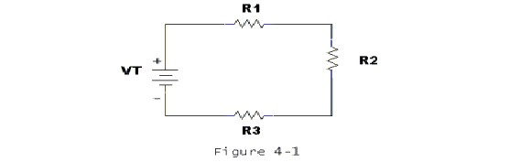  
  
How much voltage is dropped across R2 and R3 in Figure 4-1 if R1 = 4.7 kΩ, VR1 = 10 V, R2 = 4.7 kΩ and R3 = 4.7 kΩ?

|  |  |  |  |
| --- | --- | --- | --- |
|  | VR2 = 4.7 V, VR3 = 10 V | | |
|  | VR2 = 10 V, VR3 = 4.7 V | | |
|  | VR2 = 10 V, VR3 = 10 V | | |
|  | VR2 = 14.7 V, VR3 = 14.7 V | | |
| **Question 7**Correct on previous attempt(s) | |  | 1 / 1 point | |

The sum of the voltage drops in a series circuit equals the:

|  |  |  |  |
| --- | --- | --- | --- |
|  | Total resistance | | |
|  | Current in circuit | | |
|  | Source voltage | | |
|  | Resistance in branch | | |
| **Question 8**Correct on previous attempt(s) | |  | 1 / 1 point | |

milli (m) means which of these?

|  |  |  |  |
| --- | --- | --- | --- |
|  | 1 | | |
|  | 100 | | |
|  | 10-3 | | |
|  | 103 | | |
| **Question 9**Retaken | |  | 1 / 1 point | |

A 4.7 kΩ resistor has 3 mA of current passing through it. The resistor dissipates

|  |  |  |  |
| --- | --- | --- | --- |
|  | 35.2 mW | | |
|  | 42.3 W | | |
|  | 42.3 mW | | |
|  | 14.1 mW | | |
| **Question 10**Correct on previous attempt(s) | |  | 1 / 1 point | |

  
  
What is the total resistance in Figure 4-1 if R1 = 10 kΩ, R2 = 10 kΩ and R3 = 10 kΩ?

|  |  |  |  |  |  |
| --- | --- | --- | --- | --- | --- |
|  | | | 30 kΩ | | |
|  | | | infinite Ω | | |
|  | | | 0 kΩ | | |
|  | | | 3.3 kΩ | | |
|  |  |
|  | |
| **Question 1** | | | |  | 1 / 1 point |

|  |  |
| --- | --- |
| ​ |  |

|  |  |
| --- | --- |
| **Figure 6-1** | **Figure 6-2** |

|  |
| --- |
|  |

|  |
| --- |
| **Figure 6-3** |

Which of the circuits (Figure 6-1, 6-2, or 6-3) is a circuit with resistors in parallel?

|  |  |  |  |
| --- | --- | --- | --- |
|  | Figure 6-3 | | |
|  | Figure 6-2 | | |
|  | Figure 6-1 | | |
| **Question 2** | |  | 1 / 1 point | |

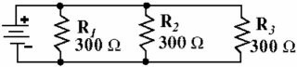

|  |
| --- |
| **Figure 6-8** |

Given the circuit in Figure 6-8, what is the total (equivalent) resistance of the circuit?

|  |  |  |  |
| --- | --- | --- | --- |
|  | 600 Ω | | |
|  | 100 Ω | | |
|  | 900 Ω | | |
|  | 30 Ω | | |
| **Question 3** | |  | 1 / 1 point | |

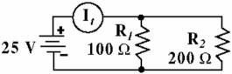

|  |
| --- |
| **Figure 6-4** |

Given the circuit in Figure 6-4, find the current through R2

|  |  |  |  |
| --- | --- | --- | --- |
|  | 125 m A | | |
|  | 0.025 A | | |
|  | 12.5 mA | | |
|  | 250 mA | | |
| **Question 4** | |  | 1 / 1 point | |

|  |  |
| --- | --- |
| **​** |  |

|  |
| --- |
| **Figure 6-5** |

Given the circuit in Figure 6-5, what is the current flowing through R2?

|  |  |  |  |
| --- | --- | --- | --- |
|  | 5.0 mA | | |
|  | 1.0 mA | | |
|  | 1.5 mA | | |
|  | 0.5 mA | | |
| **Question 5** | |  | 1 / 1 point | |

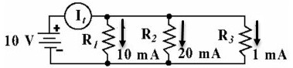

|  |
| --- |
| **Figure 6-7** |

Given the circuit in Figure 6-7, find the total power.

|  |  |  |  |
| --- | --- | --- | --- |
|  | 0.3 W | | |
|  | 310 mW | | |
|  | 310 μW | | |
|  | 0.125 W | | |
| **Question 6** | |  | 1 / 1 point | |

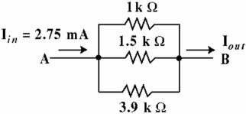

|  |
| --- |
| **Figure 6-9** |

Given the circuit in Figure 6-9, what is the total (equivalent) resistance?

|  |  |  |  |
| --- | --- | --- | --- |
|  | 6.4 kΩ | | |
|  | 5.2 kΩ | | |
|  | 520 Ω | | |
|  | 4.7 kΩ | | |
| **Question 7** | |  | 1 / 1 point | |



|  |
| --- |
| **Figure 6-9** |

Given the circuit in Figure 6-9, what is the output current (Iout)?

|  |  |  |  |
| --- | --- | --- | --- |
|  | 2.75 mA | | |
|  | 0.916 mA | | |
|  | 1.25 mA | | |
|  | 0.01 A | | |
| **Question 8** | |  | 1 / 1 point | |

Kirchhoff's law for parallel circuits states that the:

|  |  |  |  |
| --- | --- | --- | --- |
|  | sum of currents into a junction is equal to the difference of all the branch currents. | | |
|  | sum of all branch voltages equal zero. | | |
|  | sum of the total currents flowing out of a junction equals the sum of the total currents flowing into that junction. | | |
|  | total circuit resistance is less than the smallest branch resistor. | | |
| **Question 9** | |  | 1 / 1 point | |

Circuit analysis should reveal that the smallest resistance in a parallel circuit has the:

|  |  |  |  |
| --- | --- | --- | --- |
|  | most voltage | | |
|  | most current | | |
|  | least voltage | | |
|  | least current | | |
| **Question 10** | |  | 1 / 1 point | |

The total resistance of two resistors in parallel is equal to the:

|  |  |  |  |
| --- | --- | --- | --- |
|  | value of one branch resistor divided by the sum of their R values. | | |
|  | sum divided by the product of the two resistors. | | |
|  | product of their R values divided by the sum of the two resistors. | | |
|  | source voltage divided by any of the two branch resistors. | | |
| **Question 1**Correct on previous attempt(s) | |  | 1 / 1 point |

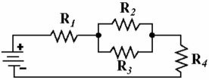

|  |
| --- |
| **Figure 7-1** |

Given the circuit in Figure 7-1, which resistors are in parallel?

|  |  |  |  |
| --- | --- | --- | --- |
|  | R2 and R4 | | |
|  | R1 and R3 | | |
|  | R1 and R4 | | |
|  | R2 and R3 | | |
| **Question 2**Correct on previous attempt(s) | |  | 1 / 1 point | |

If a 15 kΩ resistor, 0.53 MΩ resistor and 0.63 MΩ resistor are connected in parallel across an 18 V source, what is the total current if the .53 MΩ resistor opens?

|  |  |  |  |
| --- | --- | --- | --- |
|  | 12.3 mA | | |
|  | 1.23 μA | | |
|  | 0.123 A | | |
|  | 1.23 mA | | |
| **Question 3**Correct on previous attempt(s) | |  | 1 / 1 point | |

If fifteen 3.2 MΩ resistors are connected in parallel across 20 V, RT equals ________.

|  |  |  |  |
| --- | --- | --- | --- |
|  | 2.1 M Ω | | |
|  | 213 kΩ | | |
|  | 0.0213 MΩ | | |
|  | 0.125 MΩ | | |
| **Question 4**Correct on previous attempt(s) | |  | 1 / 1 point | |

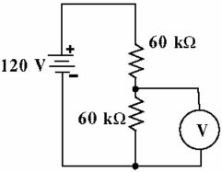

|  |
| --- |
| **Figure 7-7** |

What voltage will the meter indicate in Figure 7-7?

|  |  |  |  |
| --- | --- | --- | --- |
|  | 60 V | | |
|  | 120 V | | |
|  | 30 V | | |
|  | 45 V | | |
| **Question 5**Correct on previous attempt(s) | |  | 1 / 1 point | |

If a 470 Ω resistor, 210 Ω resistor and 75 Ω resistor are connected in parallel, what is the approximate value for RT?

|  |  |  |  |
| --- | --- | --- | --- |
|  | 22 Ω | | |
|  | 47 Ω | | |
|  | 755 Ω | | |
|  | 50 Ω | | |
| **Question 6**Retaken | |  | 1 / 1 point | |

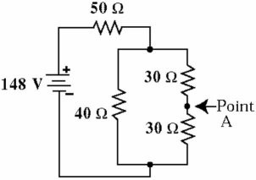

|  |
| --- |
| **Figure 7-4** |

Given the circuit in Figure 7-4, calculate the current at Point A.

|  |  |  |  |
| --- | --- | --- | --- |
|  | 0.67 A | | |
|  | 1.2 A | | |
|  | 0.8 A | | |
|  | 2 A | | |
| **Question 7**Correct on previous attempt(s) | |  | 1 / 1 point | |

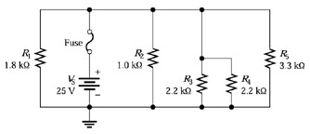

Figure 5**-1**

Refer to Figure 5-1. What is the power dissipation of R4?

|  |  |  |  |
| --- | --- | --- | --- |
|  | 189 mW | | |
|  | 568 mW | | |
|  | 284 mW | | |
|  | 11 mW | | |
| **Question 8**Correct on previous attempt(s) | |  | 1 / 1 point | |

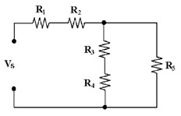

Figure 6**-2**

If all of the resistors in Figure 6-2 are 5.3 kΩ, what is the value of RT?

|  |  |  |  |
| --- | --- | --- | --- |
|  | 14.1 kΩ | | |
|  | 5.3 kΩ | | |
|  | 3.5 kΩ | | |
|  | 10.6 kΩ | | |
| **Question 9**Correct on previous attempt(s) | |  | 1 / 1 point | |

Calculate Rt in the following circuit.   
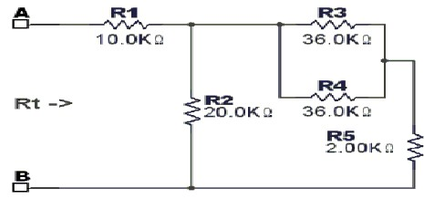

|  |  |  |  |
| --- | --- | --- | --- |
|  | 25.7 kΩ | | |
|  | 15.0 kΩ | | |
|  | 5.0 kΩ | | |
|  | 20.0 kΩ | | |
| **Question 10**Retaken | |  | 0 / 1 point | |

With the switch in the position shown, what is the value of Va in the following circuit?  
  
.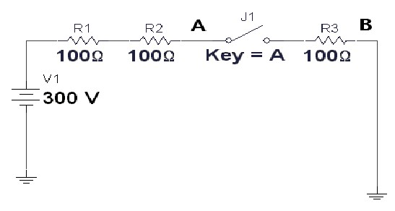

|  |  |  |  |
| --- | --- | --- | --- |
|  | | | 0 V |
| Correct Answer | | | 300 V |
|  | | | 100 V |
| Incorrect Response | | | 200 V |
|  |  |

|  |
| --- |
| 20F Hybbrid Quiz 4 |

|  |  |  |
| --- | --- | --- |
| **Question 1**Correct on previous attempt(s) |  | 1 / 1 point |

An ALU is capable of performing operations such as

|  |  |  |  |
| --- | --- | --- | --- |
|  | addition. | | |
|  | OR | | |
|  | subtraction. | | |
|  | all of the above | | |
| **Question 2**Correct on previous attempt(s) | |  | 1 / 1 point | |

Which microprocessor bus is only used to output information?

|  |  |  |  |
| --- | --- | --- | --- |
|  | Data Bus | | |
|  | Temporary Bus | | |
|  | Address Bus | | |
|  | None serve only as output busses. | | |
| **Question 3**Correct on previous attempt(s) | |  | 1 / 1 point | |

When executing an instruction, what address does the PC register contain?

|  |  |  |  |
| --- | --- | --- | --- |
|  | Address of previous instruction | | |
|  | Address of next instruction | | |
|  | Address designated by instruction operand | | |
|  | Address of current instruction | | |
| **Question 4**Retaken | |  | 1 / 1 point | |

Instruction execution consists of three phases in the following order

|  |  |  |  |
| --- | --- | --- | --- |
|  | Execute, Decode, Fetch | | |
|  | Fetch, Decode, Execute | | |
|  | Fetch, Execute, Decode | | |
|  | Decode, Execute, Fetch | | |
| **Question 5**Correct on previous attempt(s) | |  | 1 / 1 point | |

Register D is what two other registers concatenated?

|  |  |  |  |
| --- | --- | --- | --- |
|  | IX and IY | | |
|  | SP and PC | | |
|  | A and B | | |
|  | A and PC | | |
| **Question 6**Correct on previous attempt(s) | |  | 1 / 1 point | |

Register loading is under the control of

|  |  |  |  |
| --- | --- | --- | --- |
|  | the program counter | | |
|  | the condition control register | | |
|  | the clock generator | | |
|  | the control unit | | |
| **Question 7**Correct on previous attempt(s) | |  | 1 / 1 point | |

Registers A and B are

|  |  |  |  |
| --- | --- | --- | --- |
|  | 16 bit accumulators | | |
|  | 8 bit accumulators | | |
|  | 8 bit index registers | | |
|  | 16 bit index registers | | |
| **Question 8**Correct on previous attempt(s) | |  | 1 / 1 point | |

The 68HC12 CPU uses the big-endian order of the operand bytes.

|  |  |  |  |  |
| --- | --- | --- | --- | --- |
|  |  | True | | |
|  |  | False | | |
| **Question 9**Correct on previous attempt(s) | | |  | 1 / 1 point | |

The control unit is used to synchronize operations.

|  |  |  |  |  |
| --- | --- | --- | --- | --- |
|  |  | True | | |
|  |  | False | | |
| **Question 10**Correct on previous attempt(s) | | |  | 1 / 1 point | |

The 68HC12 CPU has five 16 bit registers and three 8 bit registers

|  |  |  |  |
| --- | --- | --- | --- |
|  |  | | True |
|  |  | | False |
|  |  |
|  | |

|  |  |  |
| --- | --- | --- |
| **Question 1** |  | 2 / 2 points |

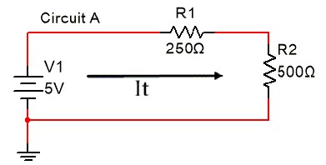  
In Circuit A, what is the measured value of VR1 as displayed on the Multimeter?

|  |  |  |  |
| --- | --- | --- | --- |
|  | 1.7 V | | |
|  | 1.67 V | | |
|  | 3.333 V | | |
|  | 1.667 V | | |
| **Question 2** | |  | 2 / 2 points | |

  
In Circuit A, what is the measured value of It  as displayed on the Multimeter?

|  |  |  |  |
| --- | --- | --- | --- |
|  | 6.67 mA | | |
|  | 6.667 MA | | |
|  | 6.667 mA | | |
|  | 3.333 mA | | |
| **Question 3** | |  | 2 / 2 points | |

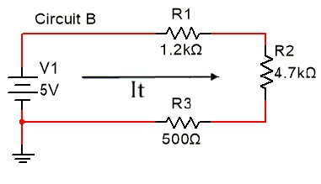  
In circuit B, what is the measured value of Rt as displayed on the Multimeter?

|  |  |  |  |
| --- | --- | --- | --- |
|  | 6.4 kOhm | | |
|  | 6.4 Kohm | | |
|  | 6.4 KOhm | | |
|  | 64000 Ohm | | |
| **Question 4** | |  | 2 / 2 points | |

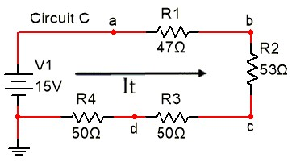  
In Circuit C, what is the measured value of Vac as displayed on the Multimeter?

|  |  |  |  |
| --- | --- | --- | --- |
|  | 7.5 v | | |
|  | 7.5 V | | |
|  | 15 V | | |
|  | 3.75 V | | |
| **Question 5** | |  | 2 / 2 points | |

  
In Circuit C, what is the measured value of Vd as displayed on the Multimeter?

|  |  |  |  |
| --- | --- | --- | --- |
|  | 3.75 V | | |
|  | 3. 8 V | | |
|  | 0 V | | |
|  | 15 V | | |
| **Question 6** | |  | 1 / 1 point | |

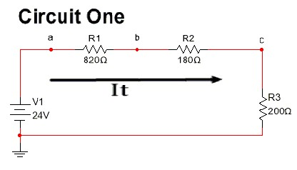  
Calculate Rt for Circuit One.

|  |  |  |  |
| --- | --- | --- | --- |
|  | 1200 Ω | | |
|  | 1200 V | | |
|  | 1020 Ω | | |
|  | 84.9 Ω | | |
| **Question 7** | |  | 1 / 1 point | |

  
Calculate It for Circuit One.

|  |  |  |  |
| --- | --- | --- | --- |
|  | 20 μA | | |
|  | 18 mA | | |
|  | 2 A | | |
|  | 20 mA | | |
| **Question 8** | |  | 1 / 1 point | |

  
Calculate Vb for Circuit One.

|  |  |  |  |
| --- | --- | --- | --- |
|  | 7.6 V | | |
|  | 9.24 A | | |
|  | 9.24 V | | |
|  | 24 V | | |
| **Question 9** | |  | 1 / 1 point | |

  
Calculate Vab for Circuit One.

|  |  |  |  |
| --- | --- | --- | --- |
|  | 7.6 V | | |
|  | 14.76 V | | |
|  | 4 V | | |
|  | 16.4 V | | |
| **Question 10** | |  | 1 / 1 point | |

  
Calculate VR3 for Circuit One.

|  |  |  |  |
| --- | --- | --- | --- |
|  | 20 V | | |
|  | 0 V | | |
|  | 4 V | | |
|  | 3.6 V | | |
| **Question 11** | |  | 1 / 1 point | |

  
Calculate  Pt  for Circuit One.

|  |  |  |  |
| --- | --- | --- | --- |
|  | 480 mW | | |
|  | 800 Ω | | |
|  | 24 V | | |
|  | 480 μW | | |
| **Question 12** | |  | 1 / 1 point | |

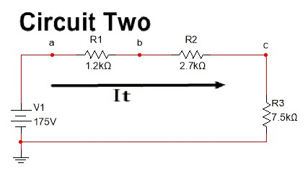  
Calculate Rt for Circuit Two.

|  |  |  |  |
| --- | --- | --- | --- |
|  | 8.7 kΩ | | |
|  | 831 Ω | | |
|  | 1202 Ω | | |
|  | 11.4 kΩ | | |
| **Question 13** | |  | 1 / 1 point | |

  
Calculate It for Circuit Two.

|  |  |  |  |
| --- | --- | --- | --- |
|  | 15.35 mA | | |
|  | 1535 μA | | |
|  | 2 mA | | |
|  | 0.1535 mA | | |
| **Question 14** | |  | 1 / 1 point | |

  
Calculate Vc for Circuit Two.

|  |  |  |  |
| --- | --- | --- | --- |
|  | 175 V | | |
|  | 115.1 kV | | |
|  | 115.1 V | | |
|  | 158.9 V | | |
| **Question 15** | |  | 1 / 1 point | |

  
Calculate Vbc for Circuit Two.

|  |  |  |  |
| --- | --- | --- | --- |
|  | 115.1 V | | |
|  | 41.4 V | | |
|  | 41.4 mV | | |
|  | 41.4 kV | | |
| **Question 16** | |  | 1 / 1 point | |

  
Calculate Vac for Circuit Two.

|  |  |  |  |
| --- | --- | --- | --- |
|  | 59.9 V | | |
|  | 175 V | | |
|  | 156.6 V | | |
|  | 18.4 V | | |
| **Question 17** | |  | 1 / 1 point | |

  
Calculate  Pt  for Circuit Two.

|  |  |  |  |
| --- | --- | --- | --- |
|  | 2.69 μW | | |
|  | 2.69 W | | |
|  | 2.69 mW | | |
|  | 175 W | | |
| **Question 18** | |  | 1 / 1 point | |

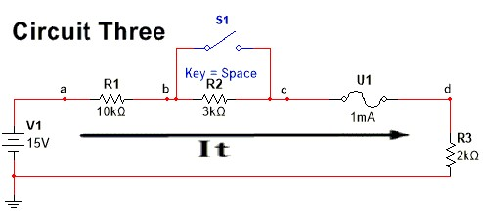  
**Calculate**Rt for Circuit Three, noting that a closed fuse has a resistance of 0 Ω.

|  |  |  |  |
| --- | --- | --- | --- |
|  | 15 mΩ | | |
|  | 0 Ω | | |
|  | 10 kΩ | | |
|  | 15 kΩ | | |
| **Question 19** | |  | 1 / 1 point | |

  
**Calculate** It for Circuit Three.

|  |  |  |  |
| --- | --- | --- | --- |
|  | 1 mA | | |
|  | 0 A | | |
|  | 10 mA | | |
|  | 10 μA | | |
| **Question 20** | |  | 1 / 1 point | |

  
With S1 in the position shown in Circuit Three, run the simulation. What is the **measured value** of Vc?

|  |  |  |  |
| --- | --- | --- | --- |
|  | 10 V | | |
|  | 0 V | | |
|  | 2 V | | |
|  | 15 V | | |
| **Question 21** | |  | 1 / 1 point | |

  
With S1 in the position shown in Circuit Three, run the simulation. What is the**measured value** of It?

|  |  |  |  |
| --- | --- | --- | --- |
|  | 0 A | | |
|  | 1 mA | | |
|  | 10 mA | | |
|  | 1 A | | |
| **Question 22** | |  | 1 / 1 point | |

In the formula It = , if Rt decreased, what is the effect on It? (Just consider the formula, not Circuit Three).

|  |  |  |  |
| --- | --- | --- | --- |
|  | Increases | | |
|  | Stays the same | | |
|  | Decreases | | |
|  | None of the above | | |
| **Question 23** | |  | 0 / 1 point | |

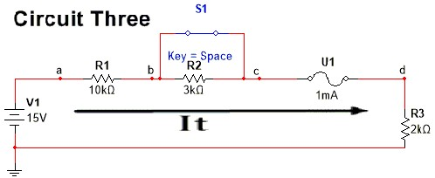  
S1 closing across R2 in Circuit Three would simulate a short-circuit across R2. **Calculate** Rt for this condition, noting that a closed switch has a resistance of 0 Ω.

|  |  |  |  |
| --- | --- | --- | --- |
| Correct Answer | 12 kΩ | | |
| Incorrect Response | 0 Ω | | |
|  | 3 kΩ | | |
|  | 15 kΩ | | |
| **Question 24** | |  | 1 / 1 point | |

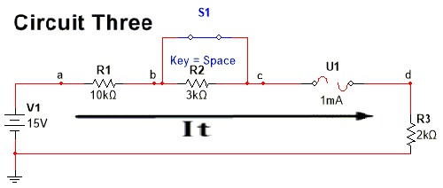  
With S1 closed in Circuit Three, the fuse will eventually blow. In that condition, it has infinite resistance and we have an OPEN circuit. Run the simulation until the fuze blows. What is the **measured value** of Vc when the fuse is blown?

|  |  |  |  |
| --- | --- | --- | --- |
|  | 2 V | | |
|  | 10 V | | |
|  | 15 V | | |
|  | 0 V | | |
| **Question 25** | |  | 1 / 1 point | |

  
With S1 closed in Circuit Three, the fuse will eventually blow. In that condition, it has infinite resistance and we have an OPEN circuit. Run the simulation. What is the **measured value** of It when the fuse is blown?

|  |  |  |  |
| --- | --- | --- | --- |
|  | | | 15 A |
|  | | | 0 A |
|  | | | 1.25 mA |
|  | | | 1 mA |
|  |  |
|  | |
| 21F CST8216 Lab Wee 4 - A1C | | | |

|  |  |  |
| --- | --- | --- |
| **Question 1** |  | 1 / 1 point |

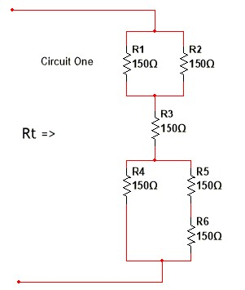  
The General Equation for Circuit One's Rt is:

|  |  |  |  |
| --- | --- | --- | --- |
|  | Rt = R1 // (R2 // R3 + R4 // (R5 + R6) | | |
|  | Rt = R1 // (R2 + R3) + R4 // R5 // R6 | | |
|  | Rt = (R1 + R2) // R3 + R4 // (R5 + R6) | | |
|  | Rt = R1 // R2 + R3 + [R4 // (R5 + R6)] | | |
| **Question 2** | |  | 1 / 1 point | |

  
The calculated value for Circuit One's Rt  is:

|  |  |  |  |
| --- | --- | --- | --- |
|  | 150 Ω | | |
|  | 200 Ω | | |
|  | 225 Ω | | |
|  | 325 Ω | | |
| **Question 3** | |  | 0 / 4 points | |

Open  in Multisim and measure the value of Rt. You should discover that the calculated value and the measured values of  Rt differ. Which of the following statements best describe your findings:

|  |  |  |  |
| --- | --- | --- | --- |
|  | Rt(measured) = 225 Ω  Rt(calculated) = 225 Ω  R2 (measured) = 150 Ω (no faulty component in circuit) | | |
| Incorrect Response | Rt(measured) = 300 Ω  Rt(calculated) = 325 Ω  R3 (measured) = ∞ Ω (infinite, R3 open) | | |
| Correct Answer | Rt(measured) = 300 Ω  Rt(calculated) = 325 Ω  R6 (measured) = 0 Ω (R6 shorted) | | |
|  | Rt(measured) = 300 Ω  Rt(calculated) = 325 Ω  R1(measured) = 0 Ω (R1 shorted) | | |
| **Question 4** | |  | 1 / 1 point | |

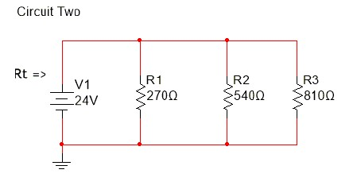  
The General Equation for Circuit Two's Rt  is:

|  |  |  |  |
| --- | --- | --- | --- |
|  | = R1 + R2 // R3 | | |
|  | = R1 + R2 + R3 | | |
|  | = R1 // R2 // R3 | | |
|  | = V1 // R1 // R2 // R3 | | |
| **Question 5** | |  | 1 / 1 point | |

  
The calculated value for Circuit Two's Rt  is:

|  |  |  |  |
| --- | --- | --- | --- |
|  | 1620 Ω | | |
|  | 324 Ω | | |
|  | 147 Ω | | |
|  | 270 Ω | | |
| **Question 6** | |  | 1 / 1 point | |

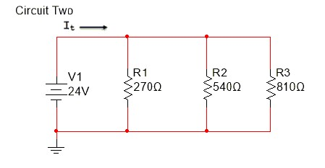  
The calculated value for Circuit Two's It  is:

|  |  |  |  |
| --- | --- | --- | --- |
|  | 74.1 mA | | |
|  | 14.8 mA | | |
|  | 88.9 mA | | |
|  | 163 mA | | |
| **Question 7** | |  | 0 / 3 points | |

Open  in Multisim and measure the value of It.  You should discover that the calculated value and the measured values of  It differ. Which of the following statements best describe your findings:

|  |  |  |  |
| --- | --- | --- | --- |
|  | It(measured) = 74.1 mA  It(calculated) = 133 mA  R2 (measured) = ∞ (R2 open) | | |
| Correct Answer | It(measured) = 74.4 mA  It(calculated) = 163 mA  R1 (measured) = ∞ (R1 open) | | |
| Incorrect Response | It(measured) = 74.4 mA  It(calculated) = 163 mA  R1 (measured) = 0 Ω (R1 shorted) | | |
|  | It(measured) = 163 mA  It(calculated) = 163 mA  No faulty component in circuit | | |
| **Question 8** | |  | 1 / 1 point | |

**For questions 8 - 14, in addition to answering the following quiz questions (1 mark each), for full credit on this Assignment, you must also submit all of your neatly *handwritten Solutions (21 marks total) in an Adobe pdf file or as a picture file of a separate sheet of 8.5" x 11" paper*  (you could use your Engineering notebook) via Submission Link for Lab Week 4 Questions 8 - 14 Calculations. When writing out your Solutions — *Include all formulas, their calculations and clearly indicate your Answers in your rough work by placing a rectangular box around the Answer*. Use correct Engineering Prefixes (e.g. k, M, m, µ, ) and correct Electronics Symbology (e.g. V, A, Ω, W) in all your solutions. Pay attention to your CaPiTaLiZaTiOn (example MV ≠ mV, K ≠ k). There is also a marking rubric on Brightspace for the written solutions submission.**

Finally, ensure that you include your Name, Student Number and Course Section Number on your submission.

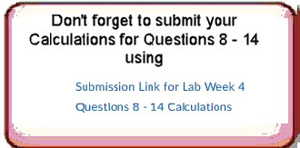

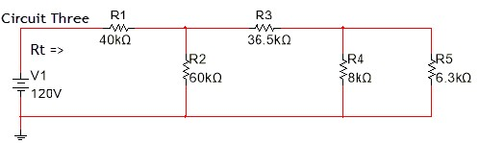

The calculated value for Circuit Three's Rt is:

|  |  |  |  |
| --- | --- | --- | --- |
|  | 140 kΩ | | |
|  | 100 kΩ | | |
|  | 40 kΩ | | |
|  | 64 kΩ | | |
| **Question 9** | |  | 1 / 1 point | |

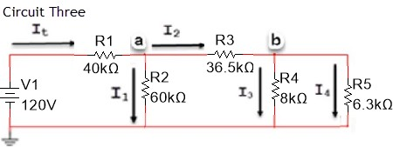

The calculated value for Circuit Three's It is:

|  |  |  |  |
| --- | --- | --- | --- |
|  | 30 mA | | |
|  | 0.857 mA | | |
|  | 1.875 mA | | |
|  | 1.2 mA | | |
| **Question 10** | |  | 1 / 1 point | |



The calculated value of Circuit Three's Va is:

|  |  |  |  |
| --- | --- | --- | --- |
|  | 72 V | | |
|  | 120 V | | |
|  | 111.43 V | | |
|  | 45 V | | |
| **Question 11** | |  | 1 / 1 point | |



The calculated value of Circuit Three's I1 is:

|  |  |  |  |
| --- | --- | --- | --- |
|  | 1.2 mA | | |
|  | 2 mA | | |
|  | 1.875 mA | | |
|  | 0.75 mA | | |
| **Question 12** | |  | 1 / 1 point | |



The calculated value of Circuit Three's I2 is:

|  |  |  |  |
| --- | --- | --- | --- |
|  | 2 mA | | |
|  | 1.125 mA | | |
|  | 0.75 mA | | |
|  | 1.2 mA | | |
| **Question 13** | |  | 1 / 1 point | |



The calculated value of Circuit Three's Vb is:

|  |  |  |  |
| --- | --- | --- | --- |
|  | 38.43 V | | |
|  | 3.94 V | | |
|  | 78.94 V | | |
|  | 3.56 V | | |
| **Question 14** | |  | 1 / 1 point | |



The calculated value of Circuit Three's I3 is:

|  |  |  |  |
| --- | --- | --- | --- |
|  | | | 4.93 mA |
|  | | | 493 μA |
|  | | | 0.0493 mA |
|  | | | 6.25 μA |
|  |  |
|  | |

**Quiz**

Top of Form

**Question 1 (1 point)**

When retrieving a value from memory, the value goes immediately to _____.

Question 1 options:

|  |  |
| --- | --- |
|  | Control Unit |
|  | ALU |
|  | Accumulator A |
|  | CPU |

**Question 2 (1 point)**

ALU performs operations on one or two operands under the control of _____.

Question 2 options:

|  |  |
| --- | --- |
|  | the System Clock |
|  | the Microcontroller |
|  | the Control Unit |
|  | the Bus Controller |

**Question 3 (1 point)**

A Flow Chart contains implementation details.

Question 3 options:

|  |  |
| --- | --- |
|  | True |
|  | False |

**Question 4 (1 point)**

Some of the things that the Design Phase of an Assembly Language program defines is _____.

Question 4 options:

|  |  |
| --- | --- |
|  | the analysis of the problem |
|  | what has to be done |
|  | user requirements |
|  | where the data and program will reside in the memory map |

**Question 5 (1 point)**

As a course standard, program data will start at memory address _____.

Question 5 options:

|  |  |
| --- | --- |
|  | 1000 |
|  | $1000 |
|  | $2000 |
|  | 2000 |

**Question 6 (1 point)**

As a course standard, program instructions will start at memory address _____.

Question 6 options:

|  |  |
| --- | --- |
|  | 1000 |
|  | $1000 |
|  | $2000 |
|  | 2000 |

**Question 7 (1 point)**

The instruction used to Load A from memory address $1000 was _____.

Question 7 options:

|  |  |
| --- | --- |
|  | adda $1001 |
|  | ldda $1000 |
|  | deca |
|  | ldaa $1000 |

**Question 8 (1 point)**

The instruction used to add the contents of memory address $1001 to A was _____.

Question 8 options:

|  |  |
| --- | --- |
|  | ldda $1000 |
|  | adda $1001 |
|  | deca |
|  | adda $35 |

**Question 9 (1 point)**

The instruction used to store the contents of A to memory $1002 A was _____.

Question 9 options:

|  |  |
| --- | --- |
|  | deca |
|  | staa $1001 |
|  | ldda $1000 |
|  | staa $1002 |

**Question 10 (1 point)**

One of the valid formats for comments when using AsmIDE is _____.

Question 10 options:

|  |  |
| --- | --- |
|  | // This is a comment |
|  | /** This is a comment */ |
|  | ; This is a comment |
|  | REM This is a comment |

**Question 11 (1 point)**

The Assembler Directive that specifief $1000 as the memory address where program data started was _____.

Question 11 options:

|  |  |
| --- | --- |
|  | db $1000 |
|  | orig $1000 |
|  | ds $1000 |
|  | org $1000 |

**Question 12 (1 point)**

Labels are symbols defining a memory address and are always placed in column 1.

Question 12 options:

|  |  |
| --- | --- |
|  | True |
|  | False |

**Question 13 (1 point)**

An example of the Assmbler Directive that is used to Define Byte, which is the value of a byte that will be placed at a given memory address is _____.

Question 13 options:

|  |  |
| --- | --- |
|  | db $25 |
|  | org $25 |
|  | ds $25 |
|  | db $1000 $25 |

**Question 14 (1 point)**

The Assembler Directive that defined storage for a byte whose value is changing or generally not known is _____.

Question 14 options:

|  |  |
| --- | --- |
|  | db |
|  | orig |
|  | ds |
|  | org |

**Question 15 (1 point)**

The memory address that instruction **adda** q uses to retrieve data from is _____.

Question 15 options:

|  |  |
| --- | --- |
|  | $1000 |
|  | $1001 |
|  | $1002 |
|  | unknown |

**Question 16 (1 point)**

The instruction used to decrement the value in Accumulator A by 1 was _____.

Question 16 options:

|  |  |
| --- | --- |
|  | ldaa 1 |
|  | adda 1 |
|  | deca |
|  | sba |

**Question 17 (1 point)**

The instruction used to store the value in Accumulator A at memory address $1002 was _____.

Question 17 options:

|  |  |
| --- | --- |
|  | ldaa $1002 |
|  | staa r |
|  | load r |
|  | stta r |

**Question 18 (1 point)**

The Program Counter (PC) always point to _____.

Question 18 options:

|  |  |
| --- | --- |
|  | the current instruction |
|  | the next instruction |
|  | the previous instruction |
|  | the next data memory address available for data storage |

**Question 19 (1 point)**

Single Stepping through a program in the simulator can be achieved by clicking on the _____ button.

Question 19 options:

|  |  |
| --- | --- |
|  | Go |
|  | Count |
|  | Step |
|  | To Return |

**Question 20 (1 point)**

The extension of the file that is loaded into the 68HCS12 Simulator is _____?

Question 20 options:

|  |  |
| --- | --- |
|  | .s19 |
|  | .asm |
|  | .lst |
|  | .sym |

**Question 21 (2 points)**

Question 21 options:

Convert Decimal -32 to its 8-bit Signed HEX and BINARY equivalents.   
Do not forget to use **$** or **%** directly in front of the entered values – e.g. **$**81 **%**10000001

HEX



BINARY



**Question 22 (2 points)**

Question 22 options:

Convert Decimal -92 to its 8-bit Signed HEX and BINARY equivalents.   
Do not forget to use **$** or **%** directly in front of the entered values – e.g. **$**81 **%**10000001   
HEX



BINARY



**Question 23 (2 points)**

Question 23 options:

Convert Decimal -82 to its 8-bit Signed HEX and BINARY equivalents.   
Do not forget to use **$** or **%** directly in front of the entered values – e.g. **$**81 **%**10000001

HEX



BINARY



**Question 24 (1 point)**

 Convert Signed HEX number $AA to its Decimal equivalent.

Decimal

Bottom of Form

**Question 25 (1 point)**

Question 25 options:

Convert Signed HEX number $80 to its Decimal equivalent.  
Decimal

-128

**Question 26 (1 point)**

What is the Unary Branch Instruction for **Branch Always** ?

Question 26 options:

|  |  |
| --- | --- |
|  | BRA |
|  | BRN |
|  | BMI |
|  | BNE |
|  | BPL |
|  | BHI |
|  | BHS |
|  | BLO |
|  | BLS |
|  | BGE |
|  | BGT |
|  | BLE |
|  | BLT |

**Question 27 (1 point)**

What is the Unsigned Branch Instruction for **<=** ?

Question 27 options:

|  |  |
| --- | --- |
|  | BRA |
|  | BRN |
|  | BMI |
|  | BNE |
|  | BPL |
|  | BHI |
|  | BHS |
|  | BLO |
|  | BLS |
|  | BGE |
|  | BGT |
|  | BLE |
|  | BLT |

**Question 28 (1 point)**

What is the Unsigned Branch Instruction for **<** ?

Question 28 options:

|  |  |
| --- | --- |
|  | BRA |
|  | BRN |
|  | BMI |
|  | BNE |
|  | BPL |
|  | BHI |
|  | BHS |
|  | BLO |
|  | BLS |
|  | BGE |
|  | BGT |
|  | BLE |
|  | BLT |

**Question 29 (1 point)**

What is the Unsigned Branch Instruction for **>=** ?

Question 29 options:

|  |  |
| --- | --- |
|  | BRA |
|  | BRN |
|  | BMI |
|  | BNE |
|  | BPL |
|  | BHI |
|  | BHS |
|  | BLO |
|  | BLS |
|  | BGE |
|  | BGT |
|  | BLE |
|  | BLT |

**Question 30 (2 points)**

Question 30 options:

Convert Decimal 85 to its 8-bit Unsigned HEX and BINARY equivalents.   
Do not forget to use **$** or **%** directly in front of the entered values – e.g. **$**81 **%**10000001   
HEX



BINARY



**Question 31 (2 points)**

Question 31 options:

Convert Decimal 192 to its 8-bit Unsigned HEX and BINARY equivalents.   
Do not forget to use **$** or **%** directly in front of the entered values – e.g. **$**81 **%**10000001   
HEX



BINARY



**Question 32 (2 points)**

Convert Decimal 240 to its 8-bit Unsigned HEX and BINARY A10equivalents.   
Do not forget to use **$** or **%** directly in front of the entered values – e.g. **$**81 **%**10000001   
HEX



BINARY



**Question 33 (1 point)**

Question 33 options:

Convert Unsigned HEX number $80 to its Decimal equivalent.  
Decimal



**Question 34 (1 point)**

Convert Unsigned HEX number $AA to its Decimal equivalent.  
Decimal



|  |  |  |
| --- | --- | --- |
| **Question 1** |  | 12 / 12 points |

Calculate Rt, It, Va and Vb in the circuit Below:

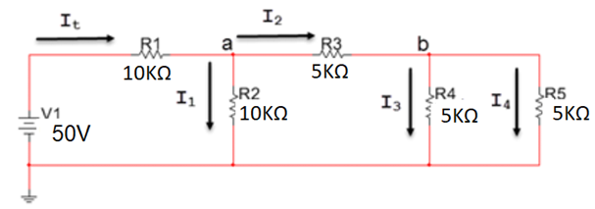

|  |  |
| --- | --- |
|  | Vb= 7 V |
|  | Va=18 V |
|  | It= 7.5 mA |
|  | It= 2.2 mA |
|  | Va=15 V |
|  | Va=12 V |
|  | It= 3.5 mA |
|  | Vb= 10 V |
|  | Rt = 16 kΩ |
|  | Vb= 5 V |
|  | Rt = 14.29 kΩ |
|  | Rt= 11.30 kΩ |

Example Question for students' practise

|  |  |  |
| --- | --- | --- |
| **Question 2** |  | 4 / 4 points |

Calculate Rt, It, VR2 and Pt for the following circuit. (4 marks)  
  
   
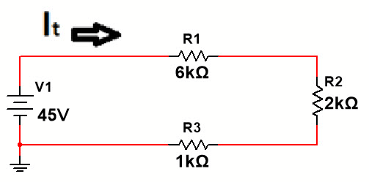  
Fill in the blanks. Pay particular attention to the units (kΩ , mA, V and mW)   
  
   
**Your answer should be only an integer number.**  
Example:  for VR1= 8.9V or 9.0V or 9.1V enter  9  
   
Rt =

___9___(25 %)

kΩ  
It =

___5___(25 %)

mA  
VR2 =

___10___(25 %)

V  
Pt =

___225___(25 %)

mW

Example S-P Question - slight rewording of Q1 from 20F

|  |  |  |
| --- | --- | --- |
| **Question 3** |  | 1 / 1 point |

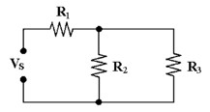

Figure 6**-1**

In Figure 6-1, R3 is connected in ________.

|  |  |
| --- | --- |
|  | parallel with R2 |
|  | series with R2 |
|  | parallel with R1 |
|  | series with R3 |

Word question example.

|  |  |  |
| --- | --- | --- |
| **Question 4** |  | 1 / 1 point |

Two resistors, an R1 of 5.6 kΩ and an R2 of 6.8 kΩ, are connected in parallel across a 12 V source. The total power dissipation for the circuit is _____.

|  |  |
| --- | --- |
|  | 46.9 mW |
|  | 25.7 mW |
|  | 4.5 mW |
|  | 21.2 mW |

Example General Question to provide students with what one of these questions would look like.

|  |  |  |
| --- | --- | --- |
| **Question 5** |  | 1 / 1 point |

An open circuit will have __________.

|  |  |
| --- | --- |
|  | maximum current flow |
|  | a small current flow |
|  | a large current flow |
|  | no current flow |

Example Measurement Question using Multisim

|  |  |  |
| --- | --- | --- |
| **Question 6** |  | 3 / 3 points |

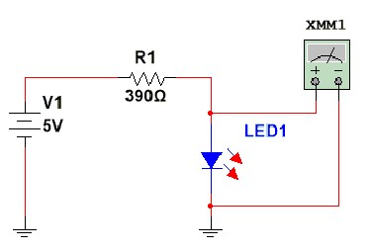

What is being measured in the above circuit?

|  |  |
| --- | --- |
|  | Rt |
|  | Vt |
|  | ILED1 |
|  | VLED1 |

Example for students

|  |  |  |
| --- | --- | --- |
| **Question 7** |  | 1 / 1 point |

A short in a series circuit results in _____.

|  |  |
| --- | --- |
|  | increased circuit resistance. |
|  | decreased or reduced current flow. |
|  | decreased power consumption. |
|  | increased or maximum current flow. |